
Yashwantrao Chavan Maharashtra Open University Nashik

PROJECT REPORT
ON

Event Management System

By
Saurabh Salvi (2016017000777206)

For
BCA (Bachelor of Computer Application)
(2018-2019)
Title

Project titled
Event Management System
Submitted
Saurabh Salvi (2016017000755965)

The Requirements for the Degree of
Bachelor of Computer Application

Study Center

St. Angelo’s Computer Education Mumbai

Certificate of Approval

This is to certify that the project report titled
Event Managment System

Is the work completed by student of BCA
Saurabh Salvi (2016017000755965)

Under the guidance of
Mr. Ankur Prajapati

Signature of the Study Centre Coordinator Signature of the Guide

Name of the Study Centre Coordinator Name of the Guide

Stamp of the Study Centre

″Event Managment System″

Synopsis
Submitted in partial fulfillment of requirements for the diploma
Of

Computer Engineering
By

Saurabh Salvi (2016017000755965)

Under the Guidance of
Prof. Ankur Prajapati

Bachelor of Computer
Application

ACKNOWLEDGEMENT

First and foremost, I have to thank our institution Saint Angelo’s for providing us a wonderful platform for sharing and presenting our idea through this project.
I would also like to show gratitude to our guide, Prof. Ankur Prajapati Without his assistance and dedicated involvement in every step throughout the process, this project would have never been accomplished. Also, we would like to take this opportunity to thank to the YASHWANTRAO CHAVAN MAHARASHTRA OPEN UNIVERSITY (YCMOU) for offering this subject.
Lastly we would like to thank all those who directly and indirectly helped in completion of this project.

EXECUTIVE SUMMARY

Event management, the very topic looks challenging. A concept which gained importance in India only after the late 90’s. Commitment, leadership and mental & physical devotion are the core factors needed to manage any type of event. Irrespective of the type or the scale of the event, the mental and physical hard work that is to be put in, differs by only a negligible degree of difference.

This terminology is comparatively very new to India, though Indians have been arranging for wedding ceremonies, naming & threading ceremonies even much before independence. But due to the lack of proper forecasting, proper material handling they used to end up in problems like wastage of the food due to less people coming in or fire in the pandal or food poisoning .These problems many a times used to put the families into financial trouble after the wedding.

It is very easy for the audiences to make the event a hit or a flop. It takes just the 5 minutes for the audiences to judge the event resulting in the efforts of nearly 3-4 months and the hard work 70-80 people either turning productive or waste. Thus the efforts they have put in always remains at stake till the date of the event.

There are innumerable activities that have to be carried out. First of all forming committees, then allotting different jobs to each committee is the very first step. Here all the theoretical concepts learnt up till now in subjects like public relations, human resource planning, logistics, human skills, controlling, accounts, organizing, and others come into actual use.

As an event manager one must have a lot of flexibility in terms of working pattern. Be free to do all sorts of jobs irrespective of your position.
.

Abstract

The purpose of Event Management System is to automate the wxisting manual system by the help of computerized eqipment and full-fledget computer software, fulfilling their requirement, so that their valuable data/information can be stored for a longer period with easy accessing and manipulation of the same. The required software and hardware are easily available and easy to work with.

Event Management System, as described above, can lead to error free, secure, reliable and fast management system. It can assist the user to concentrate on their other activities rather to concentrate on the record keeping. Thus it will help organization in better utilization of resources. The organization can maintain computerized records without redundant entries. That means that one need not be distracted by information that is not relevant,while being able to reach the information.

The aim is to automate its existing manual system by the help of computerized equipments and full-fledged computer software, fulfiling their requirements, so that their valuable data/informatin can be stored for a longer period with easy accessing and manipulation of the same. Basically the project describes how to manage for good performance and better services for the clients.

TABLE OF CONTENTS

INTRODUCTION
1.1 Introduction
1.2 Motivation
1.3 Objectives

LITERATURE REVIEW
2.1 Technology Used
HTML
CSS
Javascript
PHP
MySQL

METHODOLOGY
3.1 Meanning of the word 'Event'
3.2 Meaning of the Word 'Management'
3.3 What is Event Management
3.4 Functions of management
3.5Types Of Event Management
3.6 Software Requirements
3.7 User of Event Management
3.8 Functionality performed by customer user
3.9 Functionality performed by Admin users
3.10 Manage Customer
3.11 Manage Venues
3.12 Static Pages And Other Sections
3.13 Supported Operating System

DIAGRAM
4.1 Data Flow Diagram
- Zero Level DFD
- First Level DFD
4.2 Entity Relationship-Diagram

SCREENSHOT WITH PROJECT DETAIL
5.1 Home Page
5.2 AboutUs Page
5.3 Gallery Page
5.4 SignUp Page
5.5 Login Page
5.6 Book Venue Page
5.7 Add Hall Page
5.8 Add Event Page
5.9 Add Event_1 Page

ANALYSIS
5.1 System Analysis

Future Plan And Conclusion
6.1 Future Plan
6.2 Conclusion

BIBLIOGRAPHY
7.1 Book Reference
7.2 Website Reference

INTRODUCTION

1.1 Introduction :

Every time when you saw a programme like 'Filmfare' awards or those pop concerts and beauty pageants you would have wondered how people managed to set up such brilliant shows. Every tiny detail from your entering the venue to your going out is a result of rigorous planning. Well…that's event management for you.
One of the fastest and the most glamorous upcoming professions today, it means rubbing shoulders with who's who of the crème-de-la crème layer of the city. Event management, the most profound form of advertising and marketing, is a glamorous and thrilling profession. It provides an opportunity for unleashing one's creative potential to a very high degree. It demands a lot of hark work and effort but at the same time offers enormous scope.
Event management is a process of organizing a professional and focused event, for a particular target audience. It involves visualizing concepts, planning, budgeting, organizing and executing events such as fashion shows, musical concerts, corporate seminars, exhibitions, wedding celebrations, theme parties, product launching etc.
Event Management is a multi-million dollar industry, growing rapidly, with mega shows and events hosted regularly. Surprisingly, there is no formalized research conducted to access the growth of this industry. The industry includes fields such as the MICE (Meetings, Incentives and Events), exhibitions, conferences and seminars as well as live music and sporting events.
On the profession side, event management is a glamorous and exciting profession that demands a lot of hard work and dynamism.
The logistics side of the industry is paid less than the sales/sponsorship side, though some may say that these are two different industries..

1.2 Motivation :

Since, this is my first Internet Programming course ,I want to create a project
which is easy but also challenging. Then I decided to work Event Management.

1.3 Objectives :

The project objectives are :
To make the Event easier and comfortable
To serve the customers without wasting their precious time
To reach the Events to the customer’s Booking Easily
To represent as a compete in the Event Management of Mumbai

LITERATURE REVIEW

2.1 Technology Used

Overview of the technology :

Front End: HTML, CSS, JavaScript

HTML: HTML is used to create and save web document. E.g.
Notepad/Notepad++.

CSS : (Cascading Style Sheets) Create attractive Layout

JavaScript : It is a programming language, commonly use with web
browsers.

Back End : PHP, MySQL.

PHP: Hypertext Preprocessor (PHP) is a technology that allows software
developers to create dynamically generated web pages, in HTML, XML, or
other document types, as per client request. PHP is open source software.

MySQL Server :

MySQL is developed, distributed and supported by Oracle Corporation. MySQL
is a database system used on the web it runs on a server. MySQL is ideal for both small and large applications. It is very fast, reliable, and easy to use. It supports standard SQL. MySQL can be compiled on a number of platforms.
The data in MySQL is stored in tables. A table is a collection of related data, and it consists of columns and rows. Databases are useful when storing information Categorically MySql is a database, widely used for accessing querying, updating, and managing data in databases.
2.2 Features of MySQL :

Internals and portability :

Written in C and C++.
Tested with a broad range of different compilers.
Works on many different platforms.
Tested with Purify (a commercial memory leakage detector) as well as
with Val grind, a GPL tool.
Uses multi-layered server design with independent modules.
Security:
A privilege and password system that is very flexible and secure, and
that enables host-based verification.
Password security by encryption of all password traffic when you
connect to a server.

2.3 Connectivity :

Clients can connect to MySQL Server using several protocols :

Clients can connect using TCP/IP sockets on any platform.

On Windows systems in the NT family (NT, 2000, XP, 2003, or Vista),
clients can connect using named pipes if the server is started with the --
enable-named-pipe option. In MySQL 4.1 and higher, Windows servers
also support shared-memory connections if started with the –shared memory
option. Clients can connect through shared memory by using
the --protocol=memory option.
On UNIX systems, clients can connect using Unix domain socket files.

2.4 Localization :

The server can provide error messages to clients in many languages.
All data is saved in the chosen character set.

2.5 Clients and Tools :

MySQL includes several client and utility programs. These include
both command-line programs such as mysql dump and mysql admin,
and graphical programs such as MySQL Workbench.

MySQL Server has built-in support for SQL statements to check,
optimize, and repair tables. These statements are available from the
command line through the mysql check client. MySQL also
includes myisamchk, a very fast command-line utility for performing these operations on MyISAM tables. MySQL programs can be invoked with the --help or -? option to obtain online assistance.

2.6 Why To Use MySQL :

Leading open source RDBMS
Ease of use – No frills
Fast
Robust
Security
Multiple OS support
Free
Technical support
Support large database– up to 50 million rows, file size limit up to 8
Million TB

2.7. Hardware Requirements :

Processor: Pentium 3.0 GHz or higher
RAM: 1024 Mb or more
Hard Drive: 10GB or more

METHODOLOGY

3.1 Meanning of the word 'Event'

The use of unconventional media / method involving people witnessing a happening within acapsule of time, for the purpose of communication of a message”An event is a live multimedia package carried out with preconceived concept,customized or modified to achieve the clients’ objectives of reaching out and suitably influencingthe sharply defined, specially gathered target audience by providing at complete experience and anavenue for two way interaction.

3.2 Meaning of the Word 'Management'
’
The term management characterizes the process of and the personnelleadinganddirecting all or part of anorganizationthrough the deployment and manipulation ofresources (human,financial, material, intellectual or intangible).

According to theOxford English Dictionary, the word "manage" comes from theItalian maneggiare(to handle). Management has to do withpowerby position, whereasleadership involves power by influence.

3.3 What is Event Management?

Event management is the application of the management science of project management to the creation and development of festivals and events.

Event Management involves studying the intricacies of the brand, identifying the target audience, devising the event concept, planning the logistics, coordinating the technical aspects before getting down to actually executing the modalities of the proposed event.

The recent growth of festivals and events as an industry around the world, means that the management can no longer be ad hoc. Events and festivals, such as the Asian Games or the Dubai Shopping Festival, have a large impact on their communities and, in some cases, the whole country.

The industry now includes events of all sizes from the Olympics down to a breakfast meeting for ten business people. Every industry, charity, society and group will hold events of some type/size in order to market themselves, raise money or celebrate.

3.4 Functions of management
Management operates through various functions, often classified as planning, organizing, leading/motivating and controlling.

- Planning: Deciding what has to happen in the future (today, next week, next month, next year, over the next five years, etc.) and generating plans for action.
- Organizing: Making optimum use of the resources required to enable the successful carrying out of plans.
- Leading/Motivating: Exhibiting skills in these areas for getting others to play an effective part in achieving plans.
- Controlling: Monitoring — checking progress against plans, which may need modification based on feedback.
- Staffing: Appointing skill and unskilled workers, and efficient personnel.

3.5 Types Of Event Management

There are mainly 6 types of event management,

- wedding plarners
- personal event organisers
- birthday party planners
- live music and orchestra
- entertainment shows and stalls
- corporate/commercial event organisers

3.6 Software Requirement (any one) :

WAMP Server
XAMPP Server
MAMP Server
LAMP Server

3.7 User of Event Management:

There are two types of users available in the project :

Customer : With limited access
Admin : With full access

3.8 Functionality performed by customer user :

Registration for customer
Login for customer
Change password for customer
Edit profile for customer
View his/her Booking history
View All Venue
Customer can also track the View of the Events

3.9 Functionality performed by Admin users :

Login for admin
Edit profile for admin

3.10 Manage Customer :
View profile of the customer
Listing of all customers

3.11 Manage Venues :
Add Venue in the website
View details of the Venues
Edit the existing Venues
Listing of all Venues

3.10 Manage Booking :
View customer Booking Event
Manage Bookings is Admin
Filter and search Bookings

3.12 Static Pages And Other Sections :
Home Page with good UI
About Us page describes about the project

3.13 Supported Operating System :
Windows

DIAGRAM

4.1 DATA FLOW DIAGRAM

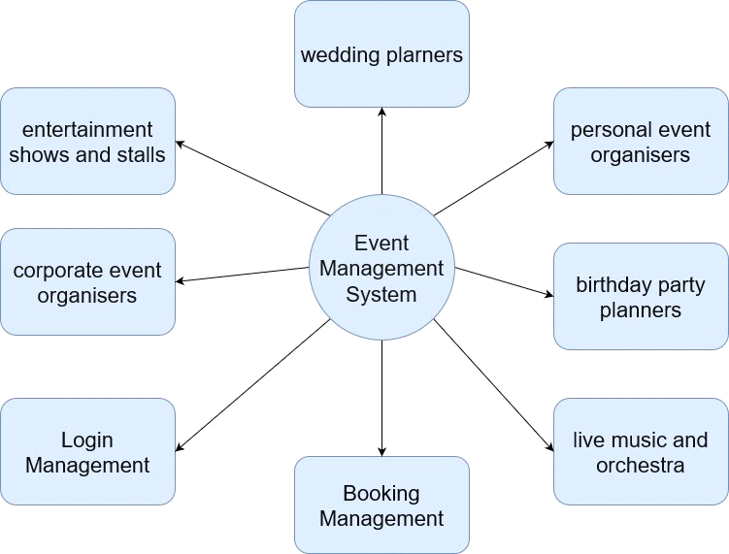

Zero Level DFD - Event Management System

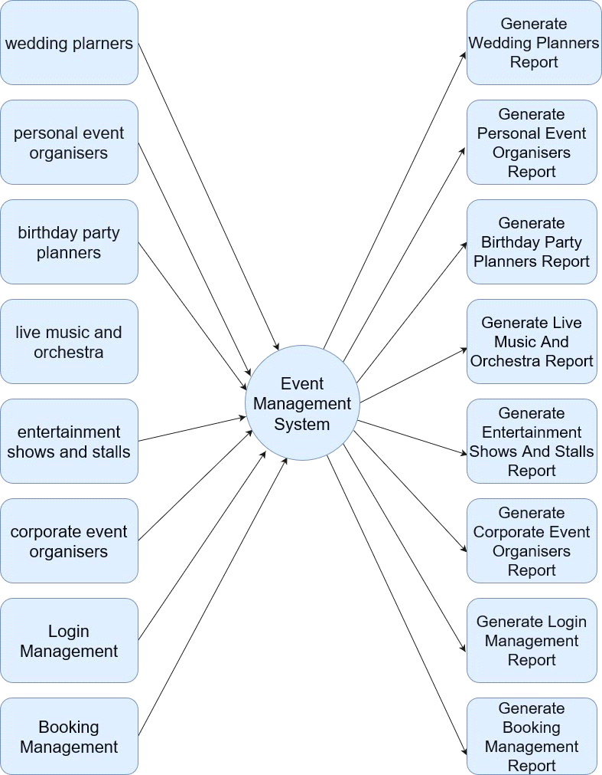

First Level DFD - Event Management System

4.2 ER DIAGRAM

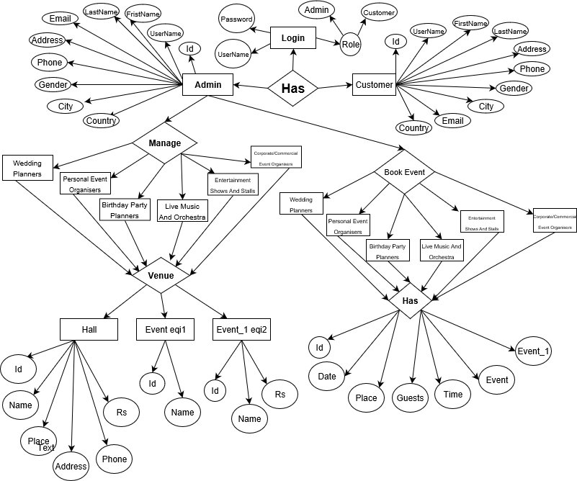

ER Diagram of Event Management System

Database: event

add_birthday_event
Column | Type | Null | Default | Comments | MIME
name | varchar(200) | No
address | varchar(500) | No
phone | int(10) | No
capacity | varchar(500) | No
event | varchar(200) | No
rs | int(200) | No
image | varchar(500) | No
id | int(200) | No

Indexes
Keyname | Type | Unique | Packed | Column | Cardinality | Collation | Null | Comment
PRIMARY | BTREE | Yes | No | id | 0 | A | No

add_corporate_event
Column | Type | Null | Default | Comments | MIME
id | int(200) | No
name | varchar(500) | No
address | varchar(500) | No
phone | int(10) | No
capacity | varchar(500) | No
event | varchar(500) | No
rs | int(200) | No
image | varchar(500) | No

Indexes
Keyname | Type | Unique | Packed | Column | Cardinality | Collation | Null | Comment
PRIMARY | BTREE | Yes | No | id | 0 | A | No

add_event
Column | Type | Null | Default | Comments | MIME
address | varchar(50) | No
phone | varchar(10) | No
capacity | varchar(50) | No
event | varchar(50) | No
rs | varchar(500) | No
name | varchar(500) | No
image | varchar(500) | No
id | int(11) | No

Indexes
Keyname | Type | Unique | Packed | Column | Cardinality | Collation | Null | Comment
PRIMARY | BTREE | Yes | No | id | 4 | A | No
name | BTREE | No | No | name | 4 | A | No

add_music_event
Column | Type | Null | Default | Comments | MIME
name | varchar(200) | No
address | varchar(500) | No
phone | int(10) | No
capacity | varchar(500) | No
event | varchar(200) | No
rs | int(200) | No
image | varchar(500) | No
id | int(200) | No

Indexes
Keyname | Type | Unique | Packed | Column | Cardinality | Collation | Null | Comment
PRIMARY | BTREE | Yes | No | id | 0 | A | No

add_personal_event
Column | Type | Null | Default | Comments | MIME
name | varchar(100) | No
address | varchar(200) | No
phone | int(10) | No
capacity | varchar(100) | No
event | varchar(50) | No
rs | int(200) | No
image | varchar(500) | No
id | int(200) | No

Indexes
Keyname | Type | Unique | Packed | Column | Cardinality | Collation | Null | Comment
PRIMARY | BTREE | Yes | No | id | 0 | A | No

add_shows_event
Column | Type | Null | Default | Comments | MIME
name | varchar(500) | No
address | varchar(500) | No
phone | int(10) | No
capacity | varchar(500) | No
event | varchar(500) | No
rs | int(200) | No
image | varchar(500) | No
id | int(200) | No

Indexes
Keyname | Type | Unique | Packed | Column | Cardinality | Collation | Null | Comment
PRIMARY | BTREE | Yes | No | id | 0 | A | No

birthday_event_eqi1
Column | Type | Null | Default | Comments | MIME
id | int(200) | No
eqi1 | varchar(100) | No

Indexes
Keyname | Type | Unique | Packed | Column | Cardinality | Collation | Null | Comment
PRIMARY | BTREE | Yes | No | id | 2 | A | No

birthday_event_eqi2
Column | Type | Null | Default | Comments | MIME
id | int(200) | No
eqi2 | varchar(500) | No
rs | int(100) | No

Indexes
Keyname | Type | Unique | Packed | Column | Cardinality | Collation | Null | Comment
PRIMARY | BTREE | Yes | No | id | 16 | A | No

book
Column | Type | Null | Default | Comments | MIME
booking_id | int(200) | No
date_ | date | No
place | varchar(500) | No
eqi1 | varchar(1000) | No
budget | varchar(500) | No
guests | varchar(200) | No
eqi2 | varchar(1000) | No
user_id | int(200) | No
name | varchar(200) | No
rs | varchar(200) | No

Indexes
Keyname | Type | Unique | Packed | Column | Cardinality | Collation | Null | Comment
PRIMARY | BTREE | Yes | No | booking_id | 20 | A | No
user_id | BTREE | No | No | user_id | 10 | A | No

contact
Column | Type | Null | Default | Comments | MIME
id | int(200) | No
name | varchar(500) | No
email | varchar(100) | No
phone | int(10) | No
city | varchar(500) | No
event | varchar(500) | No

Indexes
Keyname | Type | Unique | Packed | Column | Cardinality | Collation | Null | Comment
PRIMARY | BTREE | Yes | No | id | 5 | A | No

corporate_event_eqi1
Column | Type | Null | Default | Comments | MIME
id | int(200) | No
eqi1 | varchar(500) | No

Indexes
Keyname | Type | Unique | Packed | Column | Cardinality | Collation | Null | Comment
PRIMARY | BTREE | Yes | No | id | 9 | A | No

corporate_event_eqi2
Column | Type | Null | Default | Comments | MIME
id | int(200) | No
eqi2 | varchar(500) | No
rs | int(200) | No

Indexes
Keyname | Type | Unique | Packed | Column | Cardinality | Collation | Null | Comment
PRIMARY | BTREE | Yes | No | id | 21 | A | No

eqi1
Column | Type | Null | Default | Comments | MIME
eqi1 | varchar(200) | No
id | int(11) | No

Indexes
Keyname | Type | Unique | Packed | Column | Cardinality | Collation | Null | Comment
PRIMARY | BTREE | Yes | No | id | 9 | A | No

eqi2
Column | Type | Null | Default | Comments | MIME
id | int(200) | No
eqi2 | varchar(200) | No
rs | varchar(200) | No

Indexes
Keyname | Type | Unique | Packed | Column | Cardinality | Collation | Null | Comment
PRIMARY | BTREE | Yes | No | id | 15 | A | No

feedback
Column | Type | Null | Default | Comments | MIME
id | int(200) | No
user_id | int(200) | No
massage | varchar(500) | No

Indexes
Keyname | Type | Unique | Packed | Column | Cardinality | Collation | Null | Comment
PRIMARY | BTREE | Yes | No | id | 32 | A | No

music_event_eqi1
Column | Type | Null | Default | Comments | MIME
id | int(200) | No
eqi1 | varchar(500) | No

Indexes
Keyname | Type | Unique | Packed | Column | Cardinality | Collation | Null | Comment
PRIMARY | BTREE | Yes | No | id | 9 | A | No

music_event_eqi2
Column | Type | Null | Default | Comments | MIME
id | int(200) | No
eqi2 | varchar(500) | No
rs | int(200) | No

Indexes
Keyname | Type | Unique | Packed | Column | Cardinality | Collation | Null | Comment
PRIMARY | BTREE | Yes | No | id | 11 | A | No

music_time
Column | Type | Null | Default | Comments | MIME
id | int(200) | No
time | varchar(500) | No

Indexes
Keyname | Type | Unique | Packed | Column | Cardinality | Collation | Null | Comment
PRIMARY | BTREE | Yes | No | id | 4 | A | No

parsonal_guests
Column | Type | Null | Default | Comments | MIME
id | int(200) | No
guests | varchar(500) | No

Indexes
Keyname | Type | Unique | Packed | Column | Cardinality | Collation | Null | Comment
PRIMARY | BTREE | Yes | No | id | 4 | A | No

personal_event_eqi1
Column | Type | Null | Default | Comments | MIME
id | int(200) | No
eqi1 | varchar(100) | No

Indexes
Keyname | Type | Unique | Packed | Column | Cardinality | Collation | Null | Comment
PRIMARY | BTREE | Yes | No | id | 9 | A | No

personal_event_eqi2
Column | Type | Null | Default | Comments | MIME
id | int(11) | No
eqi2 | varchar(100) | No
rs | int(200) | No

Indexes
Keyname | Type | Unique | Packed | Column | Cardinality | Collation | Null | Comment
PRIMARY | BTREE | Yes | No | id | 16 | A | No

shows_event_eqi1
Column | Type | Null | Default | Comments | MIME
id | int(200) | No
eqi1 | varchar(500) | No

Indexes
Keyname | Type | Unique | Packed | Column | Cardinality | Collation | Null | Comment
PRIMARY | BTREE | Yes | No | id | 4 | A | No

shows_event_eqi2
Column | Type | Null | Default | Comments | MIME
id | int(200) | No
eqi2 | varchar(500) | No
rs | int(200) | No

Indexes
Keyname | Type | Unique | Packed | Column | Cardinality | Collation | Null | Comment
PRIMARY | BTREE | Yes | No | id | 11 | A | No

signup
Column | Type | Null | Default | Comments | MIME
fname | varchar(10) | No
lname | varchar(10) | No
email | varchar(50) | No
address | varchar(50) | No
phone | varchar(10) | No
gender | varchar(20) | No
city | varchar(20) | No
country | varchar(20) | No
username | varchar(10) | No
password | varchar(8) | No
canpassword | varchar(8) | No
role | varchar(500) | No
id | int(50) | No

Indexes
Keyname | Type | Unique | Packed | Column | Cardinality | Collation | Null | Comment
PRIMARY | BTREE | Yes | No | id | 24 | A | No

wedding_guests
Column | Type | Null | Default | Comments | MIME
id | int(200) | No
guests | varchar(500) | No

Indexes
Keyname | Type | Unique | Packed | Column | Cardinality | Collation | Null | Comment
PRIMARY | BTREE | Yes | No | id | 4 | A | No

SCREENSHOT WITH PROJECT DETAIL

5.1 Home Page :

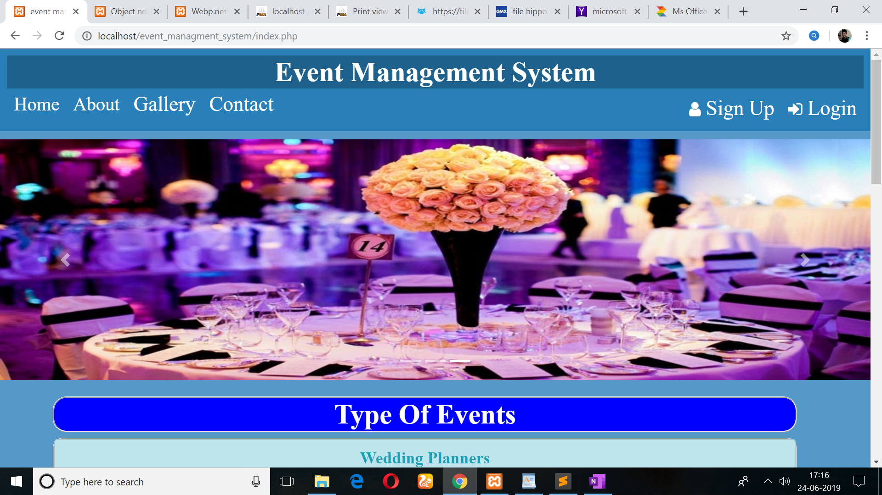

5.2 AboutUs Page :

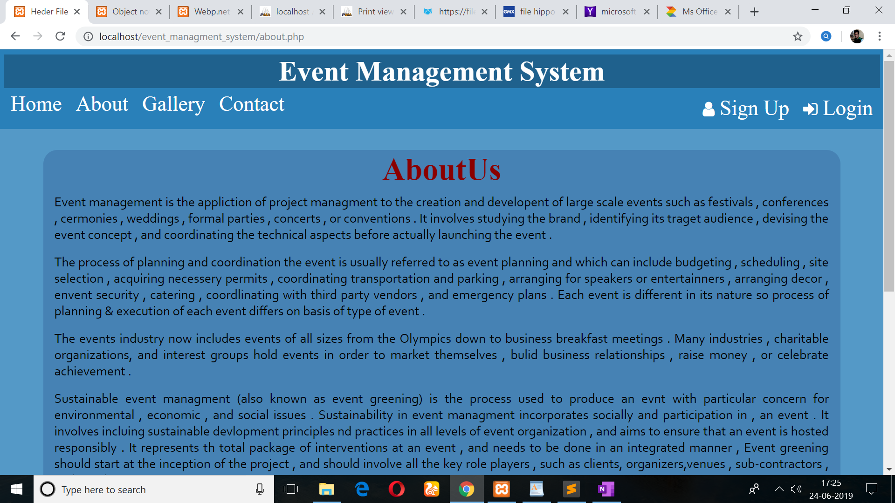

5.3 Gallery Page :

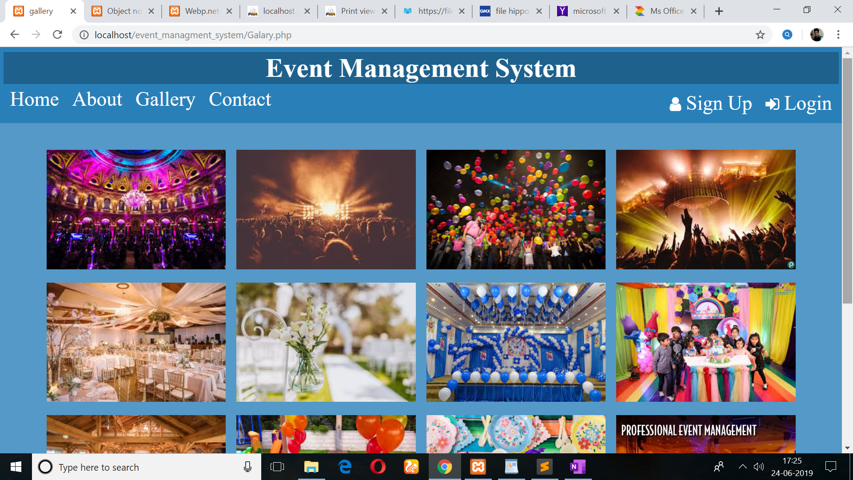
5.4 SignUp Page :

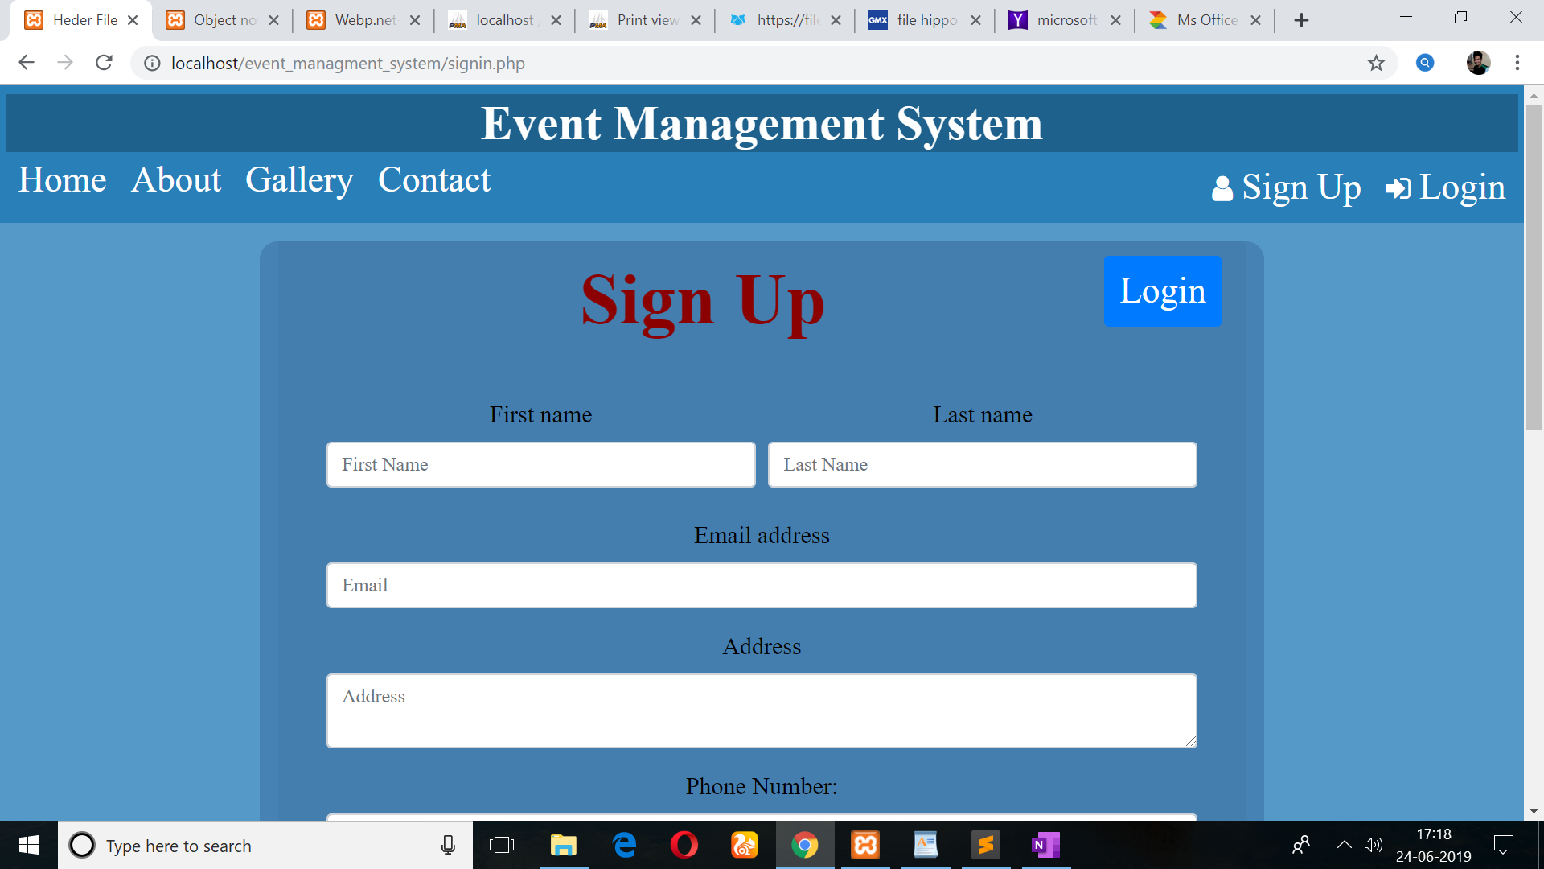

5.5 Login Page :

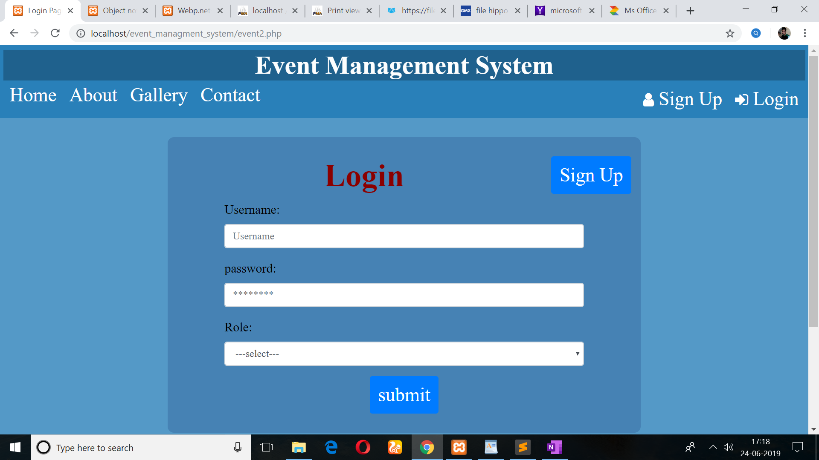
5.6 Book Venue Page :

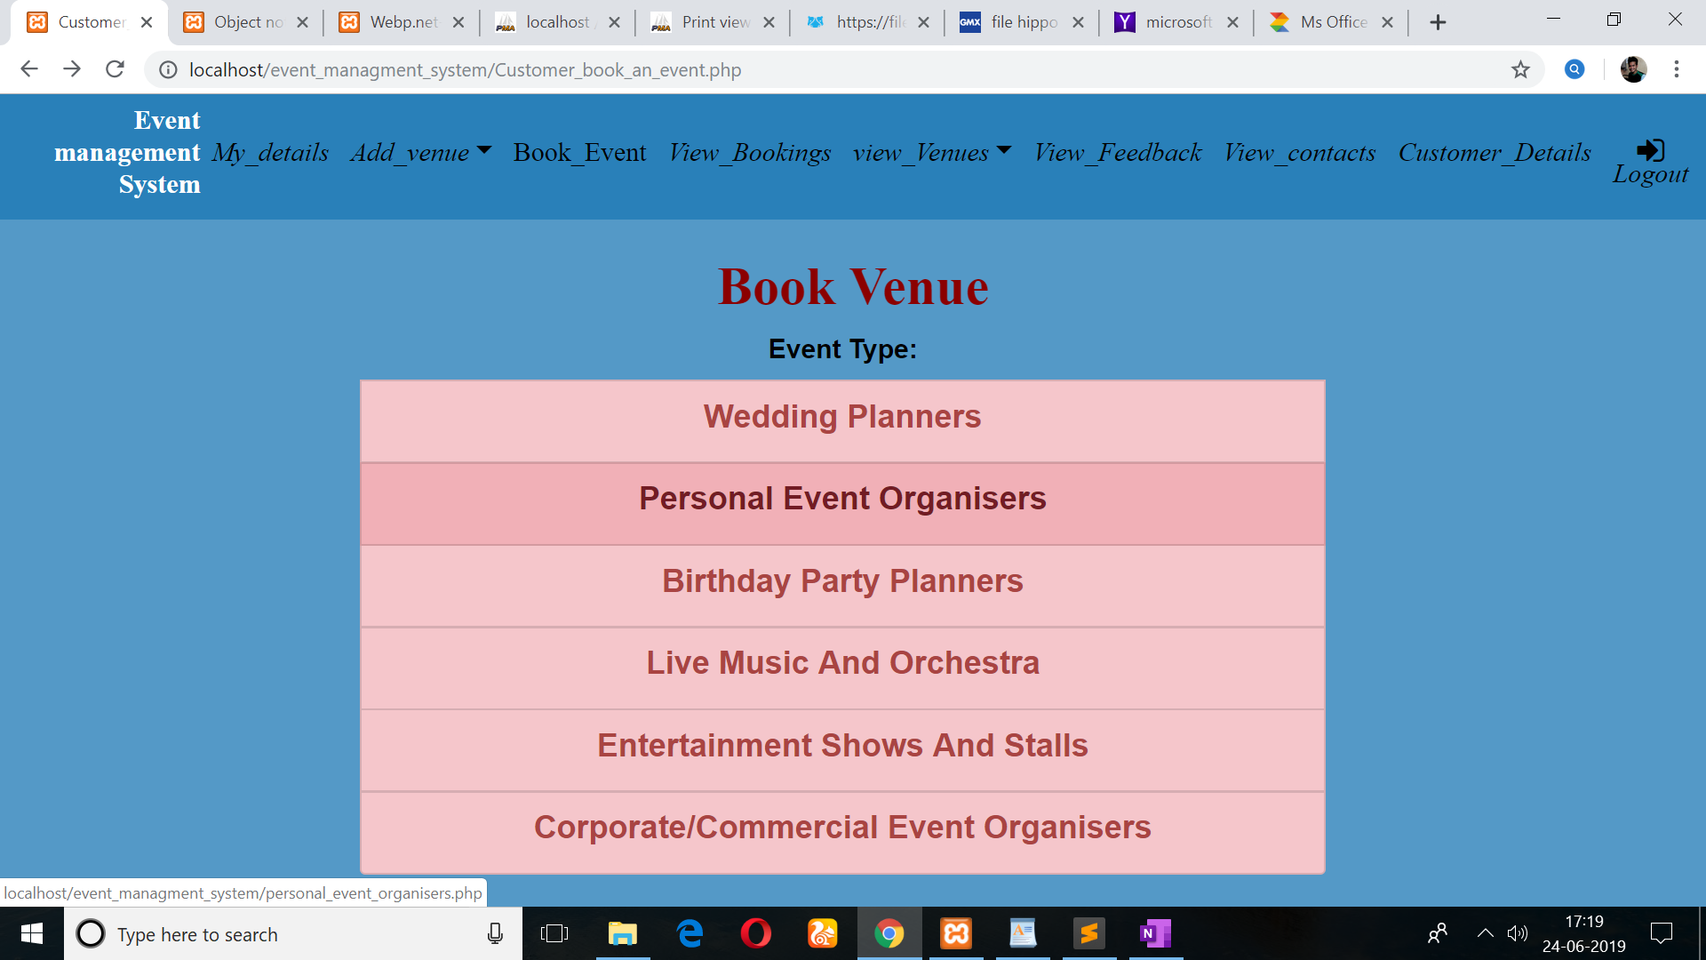

5.7 Add Hall Page :

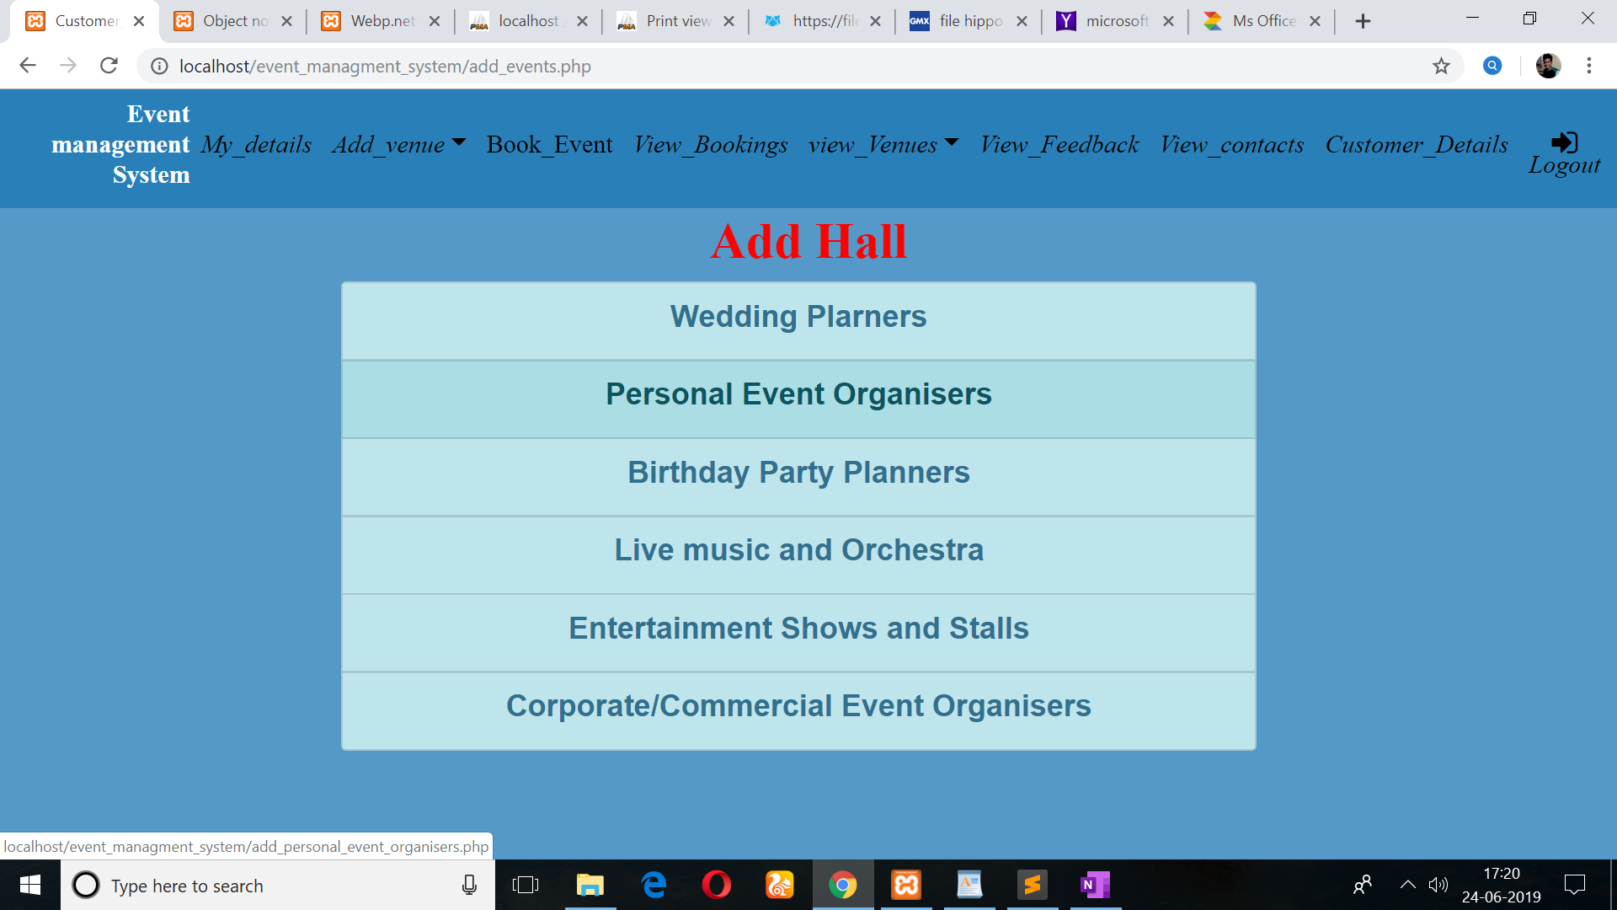

5.8 Add Event Page :

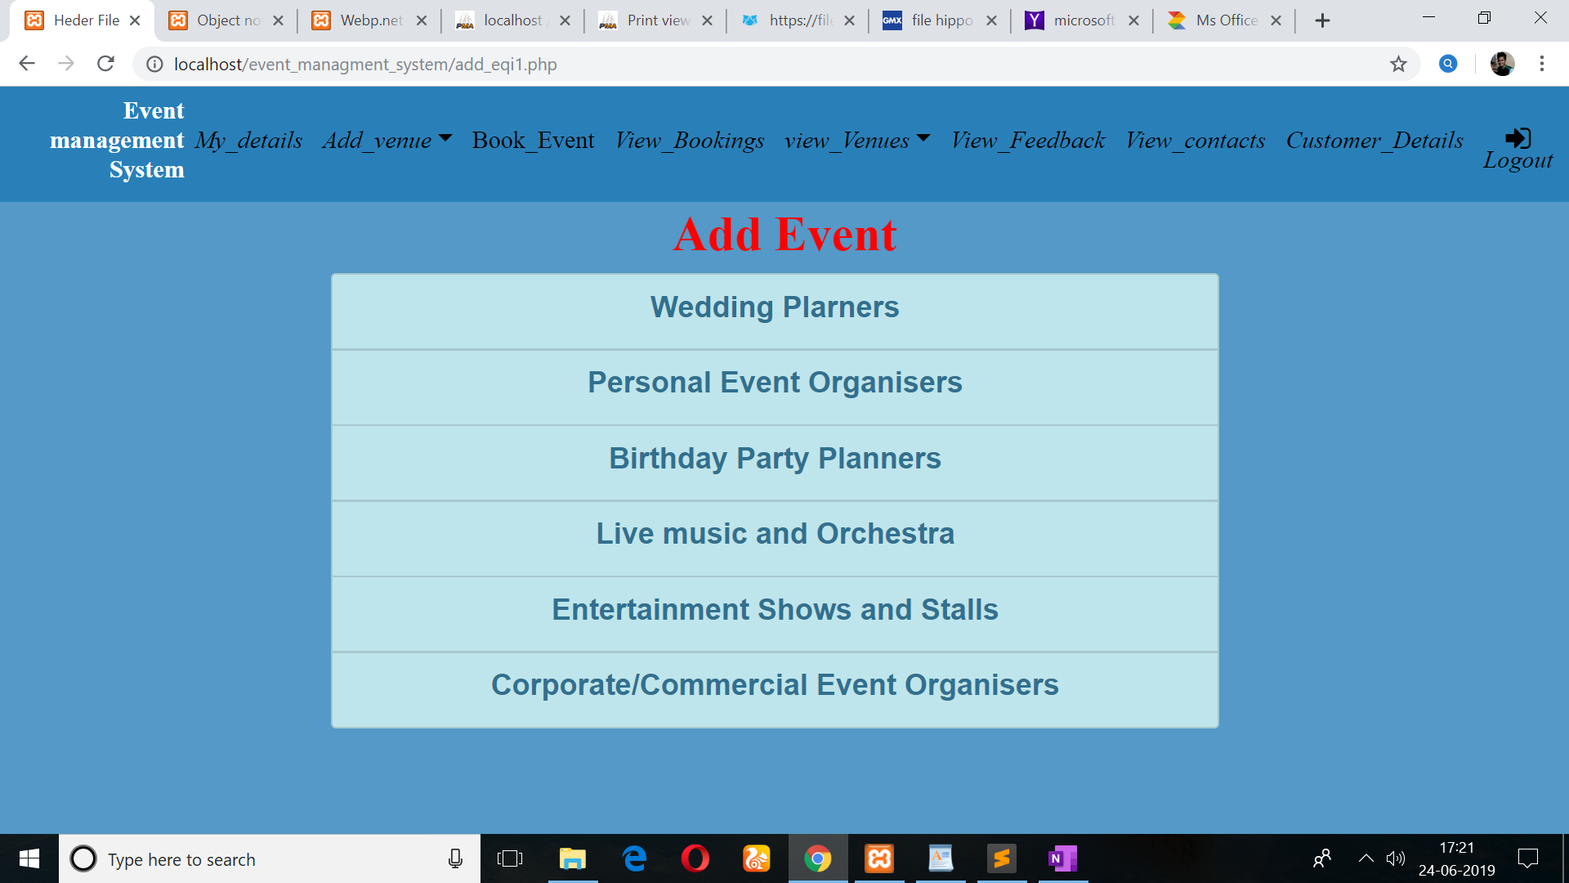

5.9 Add Event_1 Page :

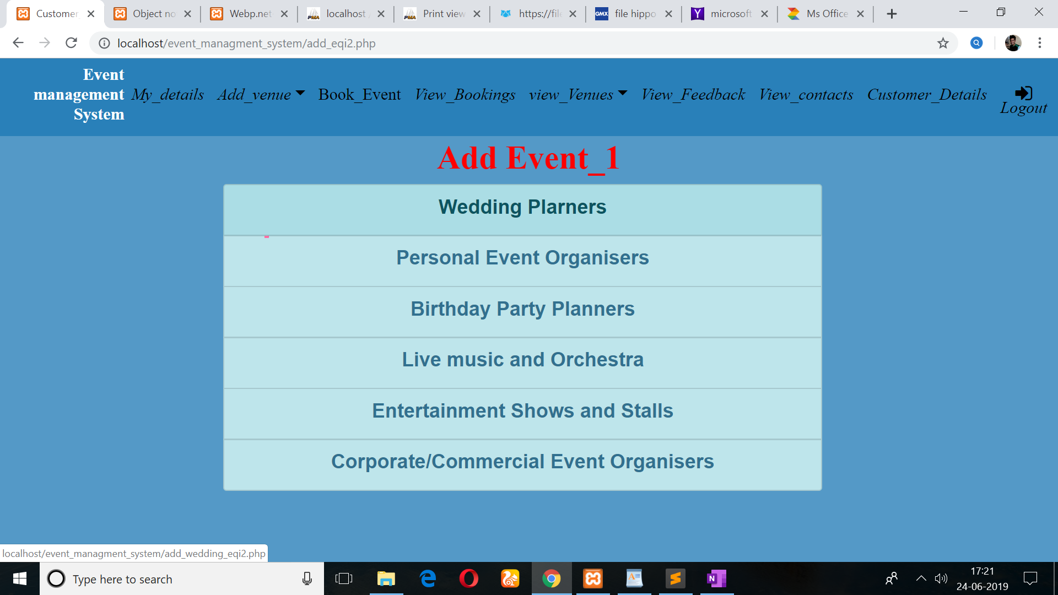

ANALYSIS

6.1 System Analysis:

System analysis is a process of gathering and interpreting facts, diagnosing problems and the information about the Event Management System to recommend improvements on the system.

It is a problem solving activity that requires intensive communication between the system users and system developers. System analysis or study is an important phase of any system development process. The system is studied to the minutest details and analyzed. The system analyst plays the role of the interrogator and dwells deep into the working of the present system.

The system is viewed as a whole and the input to the system are identified. The outputs from the organizations are traced to the various processes. system analysis is concerned with becoming aware of the problem, indentifying the relevant and decisional variables, analyzing and synthesizing the various factors and detemining an optimal or at least a satisfactory solution or program of action. A detailed study of the process must be made by various techniques like interviews, questionnares etc. The data collected by these sources must be scrutinized to arrive to a conclusion.

The conclusion is an understanding of how the system functions. This system is called the existing system. Now the existing system is subjected to close study and problem areas are identified.

The designer now functions as a problem solver and tries to sort out the difficulties that the enterprise faces. The solutions are given as proposal is then weighed with the existing system analytically and the best one is selected. The proposal is presented to the user for an endorsement by the user. The proposal is reviewed on user request and suitable changes are made. This is loop that ends as soon as the user is satisfied with proposal. Preliminary study is the process of gathering and interpreting facts, using the information for further studies on the system.

Preliminary study is problem solving activity that requires intensive communication between the system users and system developers. It does various feasibility studies. In these studies a rough figure of the system activities can be obtaines, from which the decision about the strategies to be followed for effective system study and analysis can be taken.

FUTURE PLAN AND CONCLUSION

7.1 Future Plan :

Want to Increase facilities of this project.
Want to add printing option.
Want to develop graphical design.
Want to publish this website in online.
Want to remove all the limitation

7.2 Conclusion :

Event management is a glamorous and exciting profession which demands a lot of hard workand dynamism. As the name suggests, it means conceptualizing, planning, organizing andfinally executing an event. The event could be of any type - musical show, concert, exhibition,product launching etc. This industry is just eight years old in India, but holds a lot of promisefor expansion. It offers enormous scope for ambitious young people.Event management is the planning and implementation of events, large and small that meet themarketing goals of an organization. Event management is an area that is growing rapidly, and isexpected to have a better growth rate in the next decade. Typical events organized byprofessional event managers include product launches, parties, sponsored events, sportingevents, competitions, concerts and festivals, fundraisers, trade shows, corporate open days,seminars and
tours.

BIBLIOGRAPHY

8.1 Book Reference :

Beginning PHP6,Apache,MySQL Web Development By Timothy
Boronczyk

Learning PHP, MySQL & JavaScript: With JQuery, CSS & HTML5 By
Robin Nixon

8.2 Website Reference :

https://www.w3schools.com/html/
https://www.google.com
https://www.academia.edu/4593395/Project_Report_On_Event_management
https://www.wikipedia.com

